Quadratic, cubic and reciprocal graphs
Learning Outcomes:
Bronze: Draw the graphs of quadratic and cubic functions by plotting co-ordinates
Silver: Draw the graphs of reciprocal functions by plotting co-ordinates
Gold: Recognise the type of function (quadratic, cubic, reciprocal) when given a graph

TIP: When joining up the points that you have plotted, join them with a smooth curve, not a straight line!

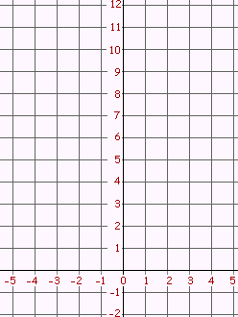
Bronze
1. a) Complete the following table for the equation: y = x² + 2,

X | -3 | -2 | -1 | 0 | 1 | 2 | 3
y |  | 6 |  | 2 |  |  | 11

b) Draw the graph of y = x² + 2 on the grid:

2. a) Complete the following table for the equation: y = x² - 1,
X | -3 | -2 | -1 | 0 | 1 | 2 | 3
y |  | 3 |  |  | 0 | 3

b) Draw the graph of y = x² – 1 on the grid:

3. a) Complete the following table for the equation: y = x³,
30
20
10
-10
-20
-30
-1
-2
-4
1
2
3
4
-3

X | -3 | -2 | -1 | 0 | 1 | 2 | 3
y | -27 |  | -1 |  |  | 8

b) Draw the graph of y = x³ on the grid:
30
20
10
-10
-20
-30
-1
-2
-4
1
2
3
4
-3

4. a) Complete the following table for the equation: y = x³ + 3,
X | -3 | -2 | -1 | 0 | 1 | 2 | 3
y |  | -5 |  | 3 |  |  | 30

b) Draw the graph of y = x³ + 3 on the grid:

Silver:
This is the graph of $y= \frac{1}{x }:$
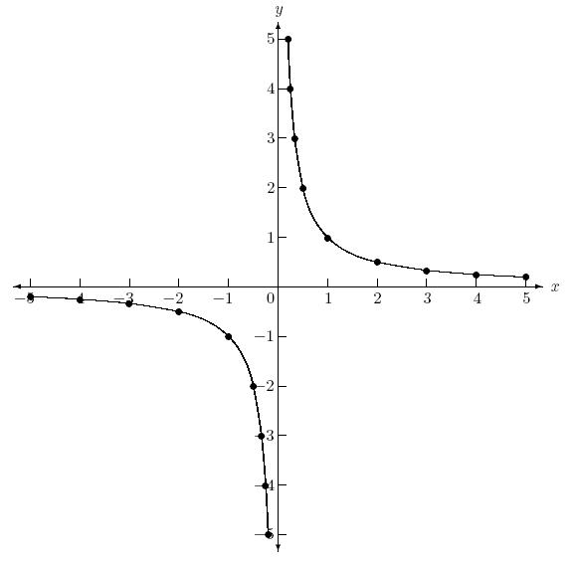

When x = 1, y = 1 because 1 ÷ 1 = 1. When x = -5, y = -1/5 because 1 ÷ -5 = -1/5. Etc…
When x = 0, no point can be plotted because any number divided by 0 is infinity.

5. a) Complete the following table for the equation: y = $\frac{3}{x}$ ,
X | -3 | -2.5 | -2 | -1.5 | -1 | -0.5 | 0 | 0.5 | 1 | 1.5 | 2 | 2.5 | 3
y | -1 |  | -1.5 | -2 |  |  | X | 6 | 3 |  |  | 1.2
-3
-2
-1
1
2
3
-2
-4
-6
2
4
6
b) Draw the graph of y = $\frac{3}{x}$ on the grid:

-3
-2
-1
1
2
3
-2
-4
-6
2
4
6

6. a) Complete the following table for the equation: y = $\frac{2}{x}$ ,
X | -3 | -2.5 | -2 | -1.5 | -1 | -0.5 | 0 | 0.5 | 1 | 1.5 | 2 | 2.5 | 3
y | -0.$\dot{6}$ |  | -1 |  |  | -4 | X |  | 2 |  |  | 0.8

b) Draw the graph of y = $\frac{2}{x}$on the grid:

Gold
7. Look back at each of the graphs you have already drawn. Can you spot a relationship between the shape of the graph and the equation of the graph?
__________________________________________________________________________________
__________________________________________________________________________________

8. Fill in the gaps using the following words: Cubic / Linear / Reciprocal / Quadratic

Equations where the highest power of x is 1 (‘x’) are called __________ equations. They create a straight line when drawn graphically.
Equations where the highest power of x is 2 (‘x²’) are called __________ equations. They create a ‘U’ or ‘n’ shape when drawn graphically.
Equations where the highest power of x is 3 (‘x³) are called __________ equations. They create a
‘ ‘ or ‘ ‘ shape when drawn graphically.
Equations that include a number divided by x (e.g. $\frac{4}{x}$) are called _________ equations. The graph never touches the axes.

9. Name the type of equation (linear/quadratic/cubic/reciprocal) for each of the following:

a) $y= 3x^{2}+ 2x+1$ __________________ b) $y= 4x^{3}+ x^{2}$ _________________
c) $y= \frac{7}{x}$ __________________ d) $y= 5x+9$ ___________________
e) $y= 4x^{2}- 5$ __________________ f) $y= 9x^{2}- 6x^{3}$ __________________

10. Write the type of equation (linear/quadratic/cubic/reciprocal) of each graph:
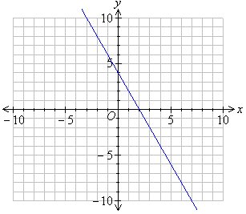
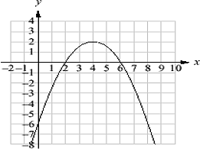
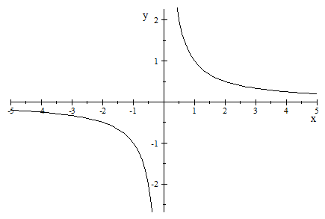
a) b) c)

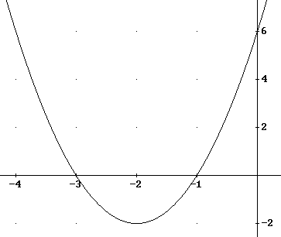
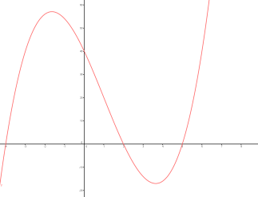
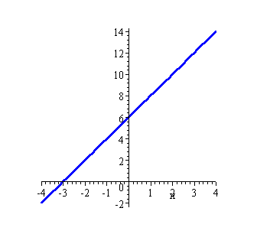
d) e) f)

11. Match the graph to the equation:

Graph ______ shows the equation y = 2x – 5
Graph ______ show the equation y = $\frac{5}{x}$
Graph ______ shows the equation y = 2x³
Graph ______ shows the equation x² – 6
Graph ______ shows the equation y = 7 - x

